Application Number | 07/2018/6450/VAR
Address | 244 Cop Lane  Penwortham  Preston  Lancashire  PR1 9AB
Applicant | Mr Tim Sayers

Agent Mr Stuart Booth
JWPC Ltd
1B Waterview
White Cross
Lancaster LA1 4XS

Development | Variation of condition No. 9 of planning approval 07/2015/1778/FUL - extension of opening hours to 08:00 - 22:00 Monday to Thursday, 08:00 - 22:30 Friday and Saturday, and 10:00 - 21:30 Sundays and Bank Holidays
Officer Recommendation | Approval with Conditions

Date application valid | 11.09.2018
Target Determination Date | 06.11.2018
Extension of Time | 12.11.2018

© Crown Copyright and database rights 2011 Ordnance Survey 100022485

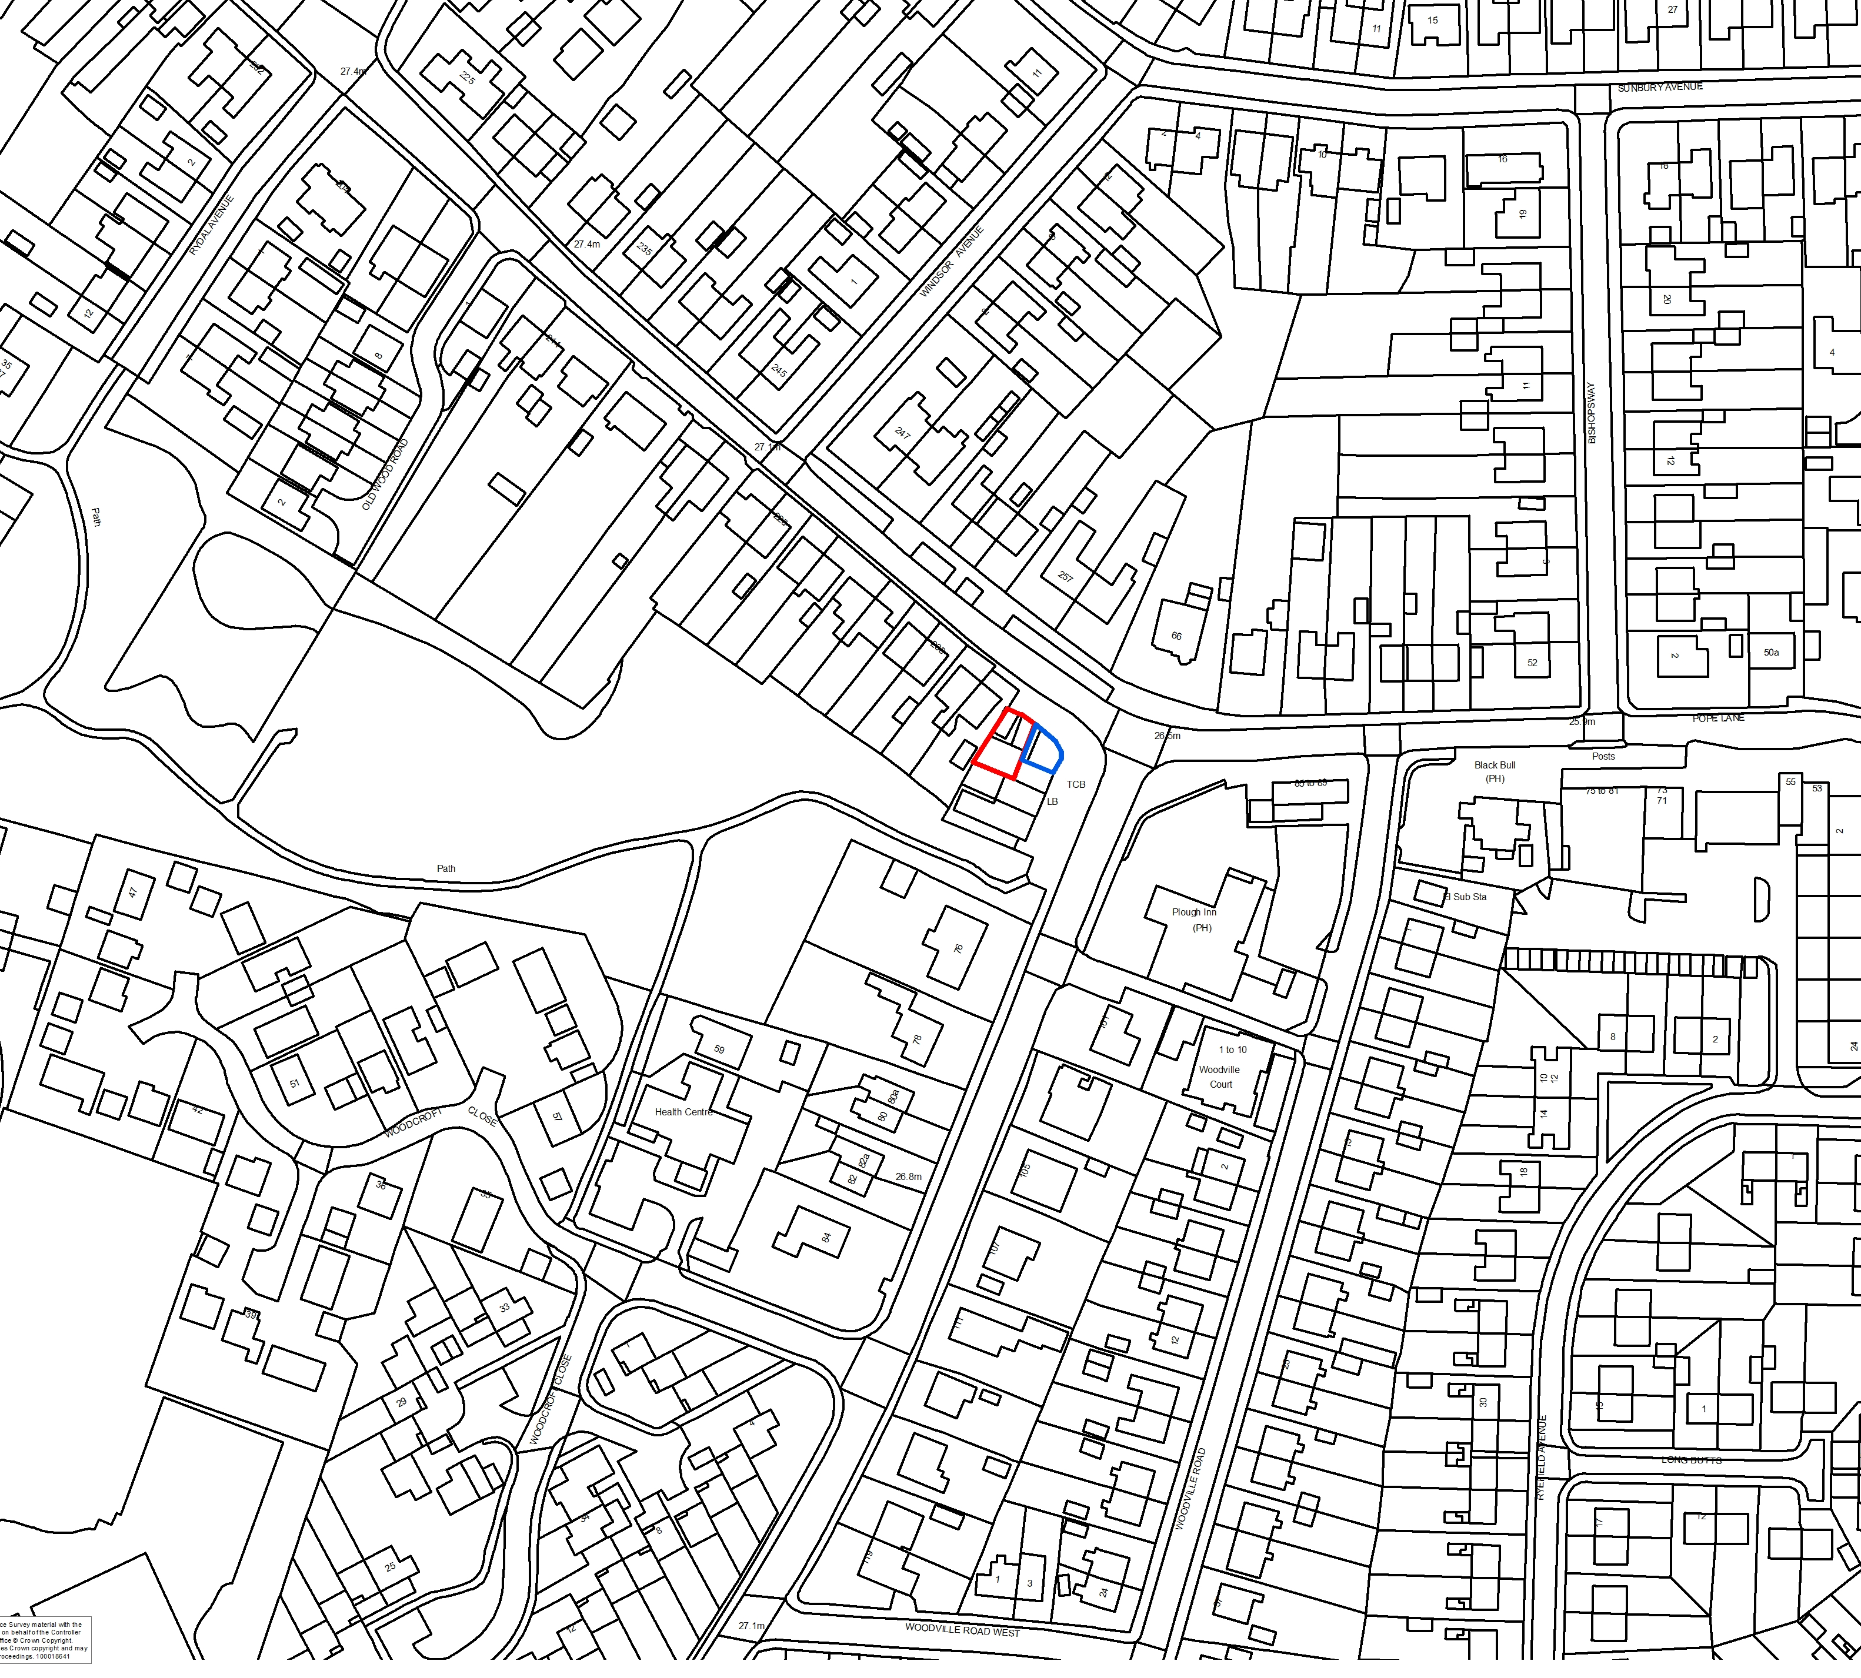

- Introduction

  - This application is brought before Committee at the request of the Ward Member

- Report Summary

  - This proposal seeks permission to extend the opening hours of premises already within the A3 (café/restaurant use class). The property is a small end of terrace unit with forecourt. It is attached to a hot food takeaway (east) and has residential facing and to the west. The former tanning salon has operated for a number of years without apparent issue, and there have been no statutory nuisance problems of concern to Environmental Health.

  - Development has been assessed by the Councils statutory consultees, and on balance is considered acceptable. Representation has been made by a number of residents as detailed in Para 6 below.

  - The property is within a designated local centre where the presumption is towards retention and support of existing ‘A’ class uses (retail and high street business), and is within easy reach of public transport options. An assessment of adjacent retail properties shows that in the main these open until later into the evening.

  - For the reasons stated in this report, it is considered that this application should be approved subject to the imposition of conditions.

- Application Site and Surrounding Area

  - The application refers to a terraced, commercial property in lawful A1/A3 use (café/restaurant), and located at the junction of Pope and Cop Lanes, Penwortham.

  - The property has a small yard to the rear accessed from a side alley, and sits within a mixed use area designated as Kingsfold Local Centre, to which Policy E5 (Local Centres) refers.

  - Immediately to the west and facing in the north are residential properties, whilst to the east and south are retail premises within the same ‘C’ shaped terrace. The property also accommodates 2 upstairs flats accessed via external staircase to the rear.

  - Off road parking in the area is generally limited to forecourt areas – there is one space designated to the property itself, but a larger forecourt to the front of adjacent properties appears to be in communal use – the neighbouring commercial unit is also in the applicant’s ownership.

- Site History

  - Other than pre-application requests, there are eight planning applications on the history of this site. The most relevant is 07/2015/1778/FUL – Change of use from tanning salon (sui Generis) to a sandwich shop/cafe (Class A3), single storey rear extension and relocation of staircase. Approved Jan 2015 and discharged by 07/2016/0592/DIS and 07/2017/1878/DIS

- Proposal

  - Description of works

    - The application proposes variation of condition 9 as imposed on 07/2015/1778/FUL to extend opening times of the café.

    - Condition 9 currently reads

‘The proposed development shall not open to the public outside the hours of 08:00-17:00 Monday to Saturday, and 10am - 3pm on Sundays or Bank Holidays.
Reason: In the interests of the amenity of the nearby residents in accordance with Policy 17 of the Central Lancashire Core Strategy and Policy G17 in the South Ribble Local Plan’.

    - The applicant wishes to change this to read

‘The proposed development shall not open to the public outside the hours of 08:00-22:00 Monday to Thursday, 08:00 – 22.30 Friday and Saturday and 10am – 21:30 Sundays and Bank Holidays.
Reason: In the interests of the amenity of the nearby residents in accordance with Policy 17 of the Central Lancashire Core Strategy and Policy G17 in the South Ribble Local Plan’.

    - Proposed variation of the condition would allow for an additional 5 hours evening opening Monday to Thursday, 5.5 hours Friday and Saturday and an extension of 6.5 hours on Sundays and Bank Holidays.

    - For comparison, other businesses also within the Kingsfold Local Centre, and which enjoy similar residential surroundings operate the following closing times. For completeness, a number of smaller daytime businesses are also present.

- Puccini takeaway (attached in the east): Monday – Thursday 10pm, Friday/Saturday 10.30 pm, Sunday 9.30pm
- Bargain Booze (20m south): 10.30 pm closure daily
- Shampan Restaurant (50m east): Monday – Saturday 11pm
- Godwin’s Fish & Chips (55m east): Monday – Friday 9pm, Saturday 8pm, Sunday closed
- Black Bull pub (100m east): Monday – Friday and Sunday 11pm, Saturday 11.30pm
- Co-Op store (120m east): 10pm closure daily

- Representations

  - Summary of Publicity

    - A site notice has been posted and twelve neighbouring properties have been consulted.

  - Letters of objection

    - 5 letters of objection have been made; their comments are summarised below:

- Insufficient parking to the shop which would get worse with extended opening hours
- Corner where business is located is an ‘accident blackspot’ and bollards which were removed without planning permission should have been retained within the forecourt.
- Increased noise and disturbance to local residents – one respondent would not object subject to 9pm closure
- Property will ultimately become a wine bar/restaurant
- Occupant of Shampan restaurant states that the café has no off road parking, and that he has closed his car park during the daytime because of the café. He is also concerned that he will lose parking for his own clients should permission to extend be granted.
- Existing litter problems caused by ‘empty pizza boxes and uneaten food’ – there is no evidence to attribute these issues to the applicants café; particularly as there are other takeaways/pizza restaurants in the immediate vicinity.

Officer Comment: Bollards mentioned were removed following continued complaint from neighbouring residents about the overall lack of parking in the area, and with the full agreement of both Borough and County Councils. The lawful A3 use already allows the premises to be used as a café or restaurant, with service of alcoholic if ancillary to the main business, and subject to separate alcohol licence as issued by the Licensing Committee. During the initial application to change the sites use, it was made clear to Planning Committee that parking on the Shampan car park would not be acceptable. A decision was made having regard to this restriction. There is no evidence that only the applicant’s clientele unlawfully use the Shampan Car Park, and policing of the neighbours car park is the owner’s responsibility.

    - In addition, comments have been made which as non-material planning considerations have not been taken into account are:

- Website is not fit for purposes and unavailable for access – comments have not been published. Comments have been made available online and have been publically available throughout the process. The consultation period was extended to cover an website issues
- Accusations that the Officer is ‘overly friendly with the applicant’ and that this should be decided by planning committee to avoid a ‘nod and a wink’ – the Officer has no personal involvement with the applicant, but in line with the requirements of the NPPF has worked with the applicant to achieve - where possible - the best outcome.
- Earlier permissions on this site have been ‘fudged to the detriment of the surrounding area’
- Occupant of Shampan objects as ‘hours of opening will clash with my own’. Competition is not a material planning consideration.

6.2.3 Penwortham Town Council also objects to the proposal which they feel would have a detrimental impact on the amenity of local residents.

  - Letters of Support

    - 27 letters of support have been received. Comments are:

- The business is a real success and Penwortham is at the moment ‘thriving with new restaurants, bars and coffee shops’, but options in Kingsfold which do not require residents to go to Liverpool Road would be welcomed
- Small family friendly café – a quiet restaurant in the area would be welcomed
- Why would there be a problem extending hours when other businesses on this busy road already open later?
- Residents should support small local businesses – the more vibrant Penwortham is the better for the local economy
- Opening later would allow residents with daytime commitments to wind down in a ‘warm, inviting place’ which is ‘great for socialising’
- The only other option in Kingsfold is The Black Bull, but not suitable for children in the evening
- Lets ‘change the perception of Kingsfold and raise its profile for positive reasons’
- Resident of 242 Cop Lane (immediately adjacent) registers their support

- Summary of Responses

  - Environmental Health have no objections to the proposal

  - Lancashire County Council Highways have no objection to the proposed variation of conditions and are of the opinion that the level of vehicle movement associated with the business would not have a severe impact on highways safety. LCC have however referred to a condition previously approved which requires installation of bollards to the front of the premises; in the main works have been done but the scheme remains incomplete. As that condition does not relate to the extension of time proposal submitted here, and the Council has no power to require completion of an extant permission within a specific time, this comment is not relevant.

- Material Considerations

  - Economic Consideration and Site Allocation

    - National Planning Policy Framework - The overarching theme of the NPPF is one of presumption in favour of sustainable development; this includes building a strong and competitive economy. It also supports the important contribution that economic opportunities offer to the community, whilst acknowledging that noise resulting from new development may also impact on quality of life (Para 180). Chapter 6 (Building a strong, competitive economy) in particular highlights the need to pursue economic growth, job creation and prosperity. Chapter 7 (Ensuring the vitality of town centres) of the same document states that planning policies should promote competitive, viable, town centre environments which are recognised as the heart of their community and provide customer choice. Although Kingsfold is allocated as a Local rather than Town Centre, the principle of the policy remain the same.

    - Local Plan 2012-2026 Policy E5 (Local Centres) refers to Kingsfold, noting that ‘A1 (retail) uses will be protected and enhanced in order to maintain the vitality and viability of the centre. Applications for other local centre uses (A2, A3, A4 and B1) may be appropriate where they do not undermine the sustainability of the shopping area.’

  - Design, Character and Appearance

    - In terms of design, Core Strategy Policy 17 and Local Plan Policy G17 both support development where design and siting are of a high quality, car parking and servicing provision are acceptable and there is no impact upon surrounding land use.

    - Although acknowledged during the initial change of use application that the property does not accord to adopted parking standards, business has been conducted on this site in one form or the other for many years. The café in question has also used the premises for a number of years, and it is unlikely that a simple extension of time during the evening, which would typically be a less busy period, would offer such detriment to the extended area as to warrant refusal. The property is limited by own capacity, and as such customers are likely to be different, rather than additional to daytime clientele.

  - Neighbouring properties

    - The only residential property which might be directly affected by this proposal is no: 242 Pope Lane whose rear garden is separated by existing 2m fences. This resident however has registered their support of the extended opening hours, and on balance any additional detriment as a result of longer hours is considered unlikely.

- CONCLUSION

  - Subject to precautionary conditions, proposed development would be in keeping with, but protective of the nature of the area, and extended environs; according to the relevant policies of the South Ribble Local Plan 2012-2026, Central Lancashire Core Strategy and National Planning Policy Framework.

  - Should permission be granted, any conditions imposed on application 07/2015/1778/FUL which have not been discharged would be carried over.

- RECOMMENDATION:

Approval with Conditions.

RECOMMENDED CONDITIONS:

1. The variation hereby permitted must be begun not later than the expiration of three years beginning with the date of this permission.
REASON: Required to be imposed pursuant to Section 91 of the Town and Country Planning Act 1990.

2. Refuse, recycling and waste materials shall only be stored to the rear of the property (as per plan GL94/E02) but shall not at any time be stored underneath the staircase. Waste materials/bins shall not be stored on the public highway or pavement adjacent to the public highway unless on the day of collection by an appropriate body. Immediately following collection, waste containers/bins shall be moved back to the recessed area. The approved area shall be retained thereafter for waste storage and for no other purpose unless otherwise agreed in writing with the Local Planning Authority.
REASON: To safeguard the character and visual appearance of the area and to safeguard the safety and living conditions of any nearby residents particularly with regard to odours, egress and/or disturbance in accordance with Policy 27 in the Central Lancashire Core Strategy and Policy G17 in the South Ribble Local Plan

3. The proposed development shall not open to the public outside the hours of 08:00-22:00 Monday to Thursday, 08:00 – 22:30 Friday and Saturday, and 10:00 – 21:30 on Sundays or Bank Holidays.
Reason: In the interests of the amenity of the nearby residents in accordance with Policy 17 of the Central Lancashire Core Strategy and Policy G17 in the South Ribble Local Plan.

RELEVANT POLICY

NPPF National Planning Policy Framework

Core Strategy Policy

Policy 5 Local Centres

Policy 17 Design of New Buildings

Local Plan 2012-2026

Policy F1 Car Parking

Policy G17 Design Criteria for New Development

Note:

Other application Informative
1. Attention is drawn to the condition(s) attached to this planning permission. In order to discharge these conditions an Application for Approval of Details Reserved by Condition form must be submitted, together with details required by each condition imposed. The fee for such an application is £116. The forms can be found on South Ribble Borough Council's website www.southribble.gov.uk

